Files in the BoardProcedures directory are organized in subdirectories covering broad functional areas. This is a File Manager picture of the some of the directory structure as of 8/4/20.
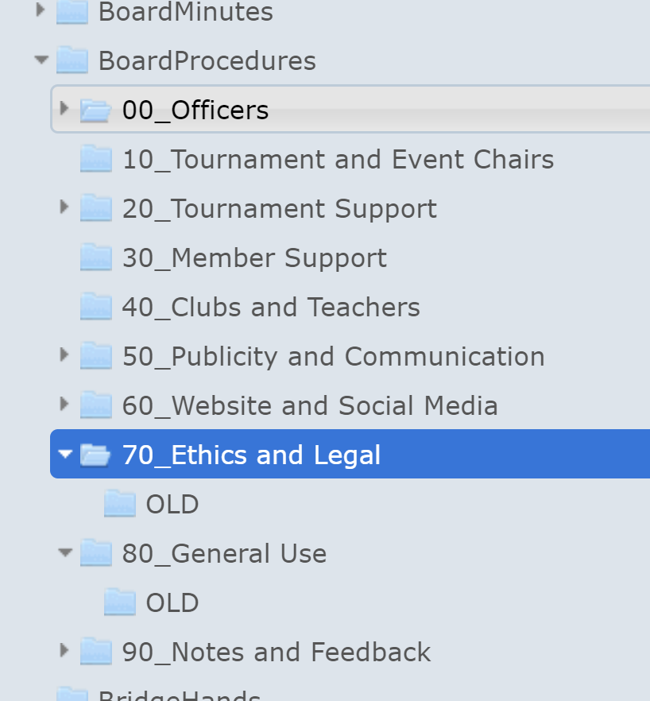
Each of these subdirectories contain files with information on the responsibilities and performance of tasks for various Unit functions.
The currently active versions of these files can be viewed on the website ABOUT DENVER BRIDGE -> BOARD PROCEDURES.
The 00_Officers directory contains a file 00_Board_Responsibilities which includes information on all the functions identified for the Unit. The directory also has files with descriptions for each of the Unit officers.
Additional directories provide “job descriptions” or “responsibilities” for various Board functions.
Some of the Directories contain information intended to be given to Unit employees (i.e. Caddies under Tournament Support). There are also files with reference information for Board Members and others in the Unit (the Tournament Schedule and Phone Lists in General Use for example). There are sometimes detailed instructions or checklists for performing specific tasks. There are also be files here with observations on future direction based on feedback.
Many files come in two forms – a Word document – for easier editing and a PDF document for easier reading within the website. Updates should attempt to include both versions.
Those of you with WordPress Editor permission will frequently see an OLD sub-directory within some of the category directories. They are used to save old versions, or unused documents that have been retained to “remember how we used to do things” - to see what we now do differently. In the case of old letterhead, to see who was on the Board back then.
All Board Members should be familiar with the contents of this file and the directory system it describes. They should also be familiar with the contents of the 00_Board_Responsibilities file, and with the additional files pertaining to their areas of responsibility. In many cases there are gaps in the current information, or additional information you would like to add. Work with experienced board members to show you how to fill in those gaps or to provide more useful information.

